Bioinformaticians of the MetaFluidics consortium gathered in Aarhus on September 18-19, 2017 to assess current NGS analysis workflows and metagenomics tools and share insights.
The second MetaFluidics bioinformatics workshop took place in Aarhus on 18th and 19th September 2017, organized and moderated by Workpackage Leader Dr. Michael Lappe, Senior Bioinformatics Scientist at QIAGEN Aarhus (Denmark). Within this forum, the 11 particpants shared their views and experiences, sharing the results obtained after 12 months of this very exciting four-year interdisciplinary and intersectoral cooperation.
Coordinated by the Universidad Autónoma de Madrid (UAM), MetaFluidics includes the participation of 5 companies, 5 universities and 3 research organizations from Denmark, Spain, France, Norway, Portugal and the United Kingdom. This project is funded with more than € 8.8 million by Horizon 2020, the European Union’s Research and Innovation Programme, under the Industrial Leadership call and the topic “Metagenomics as an innovation driver”. The objective of this collaborative research is to integrate a range of technologies into a user-friendly platform to identify genes of biotechnological interest.
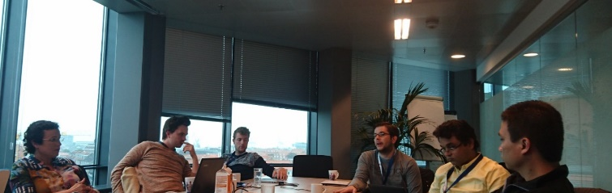
Fruitful discussions
This advanced workshop focused on obtaining an overview of state-of-the-art tools in metagenomic NGS data analysis. The main objective was to provide an interactive forum open to both consortium members and associated bioinformaticians. Within this forum, participants identified main bottlenecks, collected suggestions for alternative implementations to currently used methods and discussed possible ideas for further improvements. With bioinformatics being a key enabling technology in the metagenomics field in the near future, the findings and resulting requirement specifications will influence software development within MetaFluidics to serve the research community for the remainder of the project.
The discussions covered a wide range of current topics such as de-novo enzyme discovery, microbial genome annotation, structure-function relationships, biosynthetic pathways and meta-transcriptomics. In summary, the workshop provided a very stimulating experience with discussions on relevant issues, opening up potential further collaborations. All participants contributed insights, shared experiences from different perspectives and exchanged useful hints, tips and links.

Note to the press :
For more information on the MetaFluidics project and its activities, please check our website: www.metafluidics.eu or contact us at info@metafluidics.eu
MetaFluidics is also on social media: @MetaFluidics_EU

