**The European project METAFLUIDICS has been awarded the Madri+d prize to the most innovative EC-funded project in Madrid.**

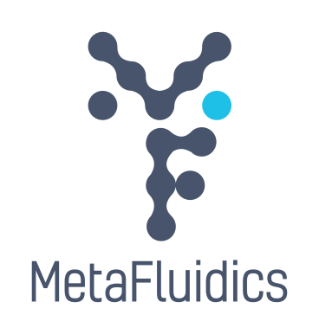

Coordinated by the Universidad Autónoma of Madrid, METAFLUIDICS includes the participation of 5 companies, 4 universities and 4 research organizations from Denmark, Spain, France, Norway, Portugal and the United Kingdom. This project is funded with more than € 8.8 million by Horizon 2020, the Research and Innovation Programme of the European Commission.

The 12th edition of the Madri+d Foundation awards recognized the METAFLUIDICS project as the most innovative EC-funded project in Madrid. Dr. Aurelio Hidalgo, Assistant Professor at the Universidad Autónoma of Madrid (Spain) and project coordinator stressed the collective effort of the consortium behind this project.

Project MetaFluidics develops technologies for enzyme discovery that are straightforwardly implemented in non-specialist labs and have the potential to become a new standard in the field. This platform will be used to identify useful enzymes for green bioenergy conversion, bioremediation, food chemistry and other industrial applications.

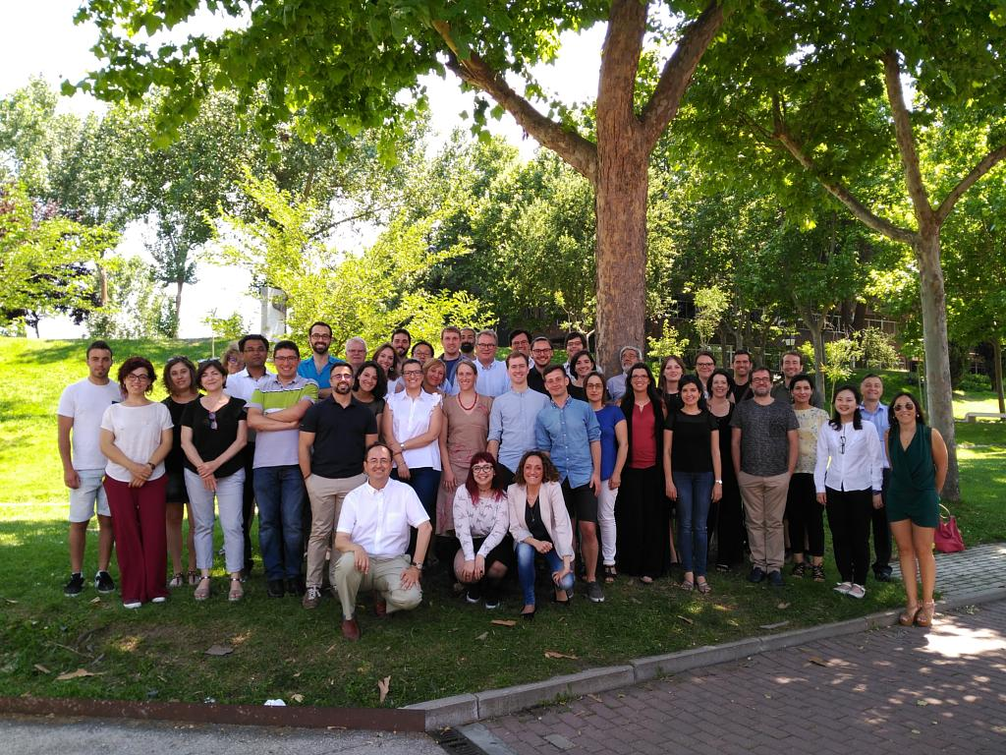

*Note to the press:*

***For more information on the MetaFluidics project and its activities, please check our website****:* [*www.metafluidics.eu*](http://www.metafluidics.eu)

***or contact us at*** [*info@metafluidics.eu*](mailto:info@metafluidics.eu)



***MetaFluidics is also on social media:***   ***@MetaFluidics_EU***