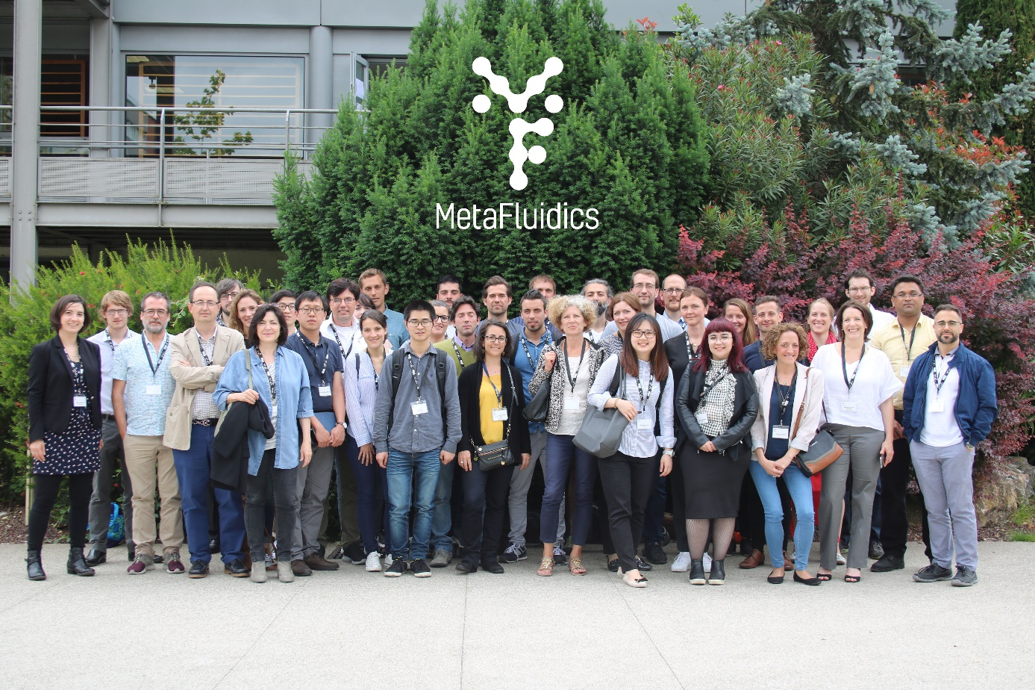

After two very active years of fruitful work, the whole MetaFluidics consortium gathered in Toulouse, France on June 5-6, 2018 to celebrate its mid-term progress. This was a fantastic opportunity for project partners to assess and share results, as well as prepare forthcoming actions.
Coordinated by the Universidad Autónoma of Madrid (UAM), MetaFluidics includes the participation of 5 companies, 5 universities and 3 research organizations from Denmark, Spain, France, Norway, Portugal and the United Kingdom. This project is funded with more than € 8.8 million by Horizon 2020, the European Union’s Research and Innovation Programme, under the Industrial Leadership call and the topic “Metagenomics as an innovation driver”. The objective of this collaborative research is to integrate a range of technologies into a user-friendly platform to identify genes of biotechnological interest.
Over the past two years, the project partners have been busy sampling the natural (extreme) biodiversity to create new metagenomic libraries and find relevant genes, enzymes and molecules present in extremophile microorganisms, among others. They have also developed new enrichment methods and screening assays, making use of microfluidics, the manipulation of liquids at a micrometric scale. Thanks to novel droplet microfluidic systems based on the miniaturization of the reaction to picoliter droplets, MetaFluidics enables ultrahigh-throughput screening and saves time and money while increasing the odds of finding one in a million hits. We can screen 1000-fold faster and reduce costs by 1000-fold compared with conventional methods, and we therefore expect to establish microfluidic droplets as the future standard for metagenomic library expression and screening.
We are now putting all these methods in practice to screen the biodiversity. In particular, partners showed progress in the screening of enzymes using different hosts, including extremophiles, to access as much biodiversity as possible. A wide range of assays was presented: to screen for enzymes or genes, both naive and sequence-based, single-step conversions or cascade reactions. In a word, we are getting closer and closer to the lab-on-a-chip.
Very useful exchanges took place during the meeting in Toulouse, both in terms of method optimization and on how to best exploit the cutting-edge science that is being done and the technology that is being developed. In particular, MetaFluidics is actively seeking to expand the number of its stakeholders and to establish synergies with other EU-funded projects.
Dissemination of the project results has been quite active too with 12 planned or effective publications in various peer-reviewed scientific journals and regular participation in international events and conferences. Communication and outreach to the general public are also taken very seriously, with a strong presence in the upcoming ESOF 2018 events in Toulouse: one scientific session entitled “Going to extremes” will be presented during the Forum, while the MetaFluidics team will also be present in the “Science in the City” village to show adults and children that proteins and microbes can have superpowers!. The official project video will also be released soon and other communication actions are planned in the coming weeks or months.
For more information on the MetaFluidics project and its activities, please check our website: www.metafluidics.eu or contact us at info@metafluidics.eu.
MetaFluidics is also present on social media:
- Twitter : @MetaFluidics_EU
- Facebook : https://www.facebook.com/MetaFluidics_EU-335684966791474/
- LinkedIn : https://www.linkedin.com/groups/10325253/profile
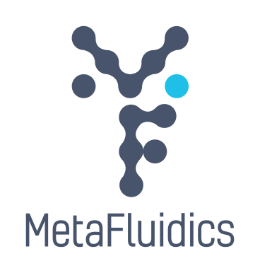
- Instagram: @metafluidics_eu

